[1]

An improved method of gamma scanning assay for 400L highly compressed radioactive wastes drum basing on equivalent ring source

Weiguo GU, Xinhai TANG, Dezhong WANG, Yuanwei MA, Kaiyuan RAO

*Abstract*—Aiming at 400 liter drum with low and intermediate level radioactive wastes which are highly compressed, an improved gamma scanning assay and its algorithm are proposed basing on equivalent ring source. The numerical measurements are carried out where three common nuclides (Ba-133, Cs-137, Co-60) and two waste densities (1.5, 2.5 g/cc) are considered. The reconstructed results show that the improved method distinctly exhibits the very good performance in detecting the large and highly compressed radioactive wastes drum. The whole maximal errors of the improved method are several times smaller than that of SGS, and the mean errors are reduced nearly in half for all nuclides.

*Index Terms*—Non-destructive assay, improved gamma scanning, radioactive waste, 400 liter drum

# INTRODUCTION

For the purpose of volume reduction, the compaction of solid radioactive wastes in 400 liter drum is adopted presently in the waste treatment in the nuclear power plant. The widely used method to assay the amount and categories of radioactive nuclides within the waste drum is segmented gamma scanning (SGS) [1], one method of non-destructive assay techniques. Due to the assumption of both drum matrix and radionuclides being homogeneously distributed within the drum, large assay errors will be resulted in when the distribution is not homogeneous in the practical condition [2]. As a result, tomographic gamma scanning (TGS) is proposed by using a lot of small voxels to reconstruct the distribution of matrix and radioactivity [3]. However, when the radioactive wastes are compressed with more than two times density as high as water and the volume increases from widely used 200 liter to 400 liter, the large attenuation of gamma rays by the matrix will cause SGS exhibiting large assay error. Meanwhile, TGS will also meet some problems, such as the low counting statistics in the case of gamma rays being difficult to penetrate the matrix [4]. Moreover, due to the high attenuation, detection efficiency of small voxels will be distributed extremely unevenly, which will amplify the iteration residual during TGS image reconstruction.

In order to improve the detection accuracy, some new and improved approaches were proposed mainly aiming at 200 liter waste drum using gamma-ray scanning method. Dynamic grids [5][6] and semi-TGS [7] techniques were applied in TGS in order to reduce voxels’ number, but it was difficult to resolve the problems met by TGS when the density was large in 400 liter drum. TGS was proposed originally to reconstruct the heterogeneous matrix and activity distribution, however some studies proved that reasonable results could be obtained if heterogeneous mass distributions were assumed [8]. If the matrix is assumed to be homogeneously distributed, the assay process becomes simple and point sources will be equal to ring sources when the waste drum is rotated continuously. An improved SGS method was proposed basing on the assumption of one ring source which was obtained by weighted average of all ring sources in the segment [9]. If the location of the ring source was determined, the detection efficiency could be calibrated accurately according to the source location and the assay accuracy would be improved. However, the results of this method showed that this method was suitable to few sources and low matrix density. Another complicated method to determine the source location was applied a techniques combining gamma emission tomography with SGS [10].

In non-destructive assay techniques to assay the waste drum, the difficulty in positioning the radioactive sources will lead to the detection efficiency and radioactivity assay exhibiting large error, which will be enhanced for the compressed waste drum. This paper aims at the heterogeneous activity distribution in 400 liter waste drum with highly compressed matrix, and proposes an improved gamma scanning method basing on equivalent ring source.

# PRINCIPLES

As shown in Fig.1, the high purity germanium (HPGe) spectrometer employing a lead collimator is used to scan gamma rays. The waste drum is rotated at a constant speed, every point nuclide source can be regarded as a ring source after several whole circles’ integral. The waste drum is divided into several axial segments, the detector is lifted step by step toward each segment and counts gamma rays.

When the detector is in the *k*-th segment, the count rate (*Ck*) of gamma rays emitted by one type of nuclide will contain all contributions from the segments within the collimator’s vision.

 （1）

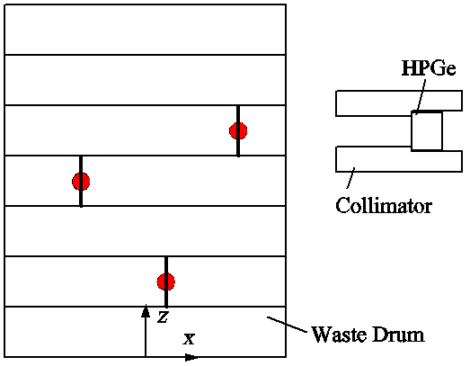

(a) Layout in x-z plane

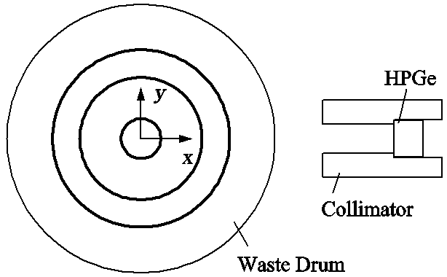

(b) Layout in x-y plane

Fig. 1. The schematic of gamma scanning method.

In Eq.1, *Ck* is concluded by the net area of full-energy peak of one nuclide, *α* is the branching ratio of gamma line, *An* is the activity of one nuclide with the serial number of *n*. Here, the nuclides in the waste drum are all numbered according to the geometric position, *N* is the total number. *Enk* is the detection efficiency of the nuclide with serial number *n* to the detector which is in the *k-*th segment. The detection efficiency is calibrated by assuming the source as a cylinder source when the drum is rotated. The cylinder radius is decided by the radial distance of the point source to the drum axis, the height is equal to the segment height. The detection efficiency curves are shown in Fig.2 versus different cylinder radius in different segment. The nuclide is Cs-137, and the matrix density is 2.5 g/cc. The label “Segment +0” in the figure denotes the segment with the height similar with the detector, and “Segment +1” denotes the segment above or below the detector by one segment, and so on. It is found that the detection efficiencies in “Segment +0” and “Segment +1” increase versus the source radius. But they are very small in “Segment +2”, so the gamma rays from “Segment +2” are ignored. Eq.1 is simplified as follows.

（2）

In Eq.2, *An*-1, *An*0, *An+*1 are activities of one nuclide in the three neighboring segments which are close to the detector. The detection efficiency (*Enk*) depends on nuclide’s energy, waste’s density and relative position of radioactive sources to the detector. If the matrix is homogeneous, the detection efficiency will be identical if the relative position of the source to detector is same. If the source is located in the segment with the same height of the detector, the detection efficiency is *E*(*r*)0 for the source with the radius of *r*. And If the source is located in the segment neighboring to the detector, the detection efficiency is *E*(*r*)+. So if all count rates are merged into the total count rate, Eq.2 is changed as follows.

 （3）

In Eq.3, *En*0, *En*+ are detection efficiencies of the nuclide with serial number *n* to the detector when the nuclide is located in “Segment +0” and “Segment +1”. Because the assay is started when the detector is in the first segment and ended in the *K*-th segment, two assay positions which are below the first segment or above the *K*-th segment are lost, where *K* is the total number of segments. This is called "end loss". Eq.3 excludes the count rates from the two lost positions. To resolve this problem, one method is to complete the assay in the two positions, the other method is to estimate the activities in the firstor *K*-th segment according to the mean activity in the whole waste drum. The second method is adopted because the detection efficiency of *E*+ is smaller than *E*0 and it will not cause large error. So Eq.3 is changed as follows.

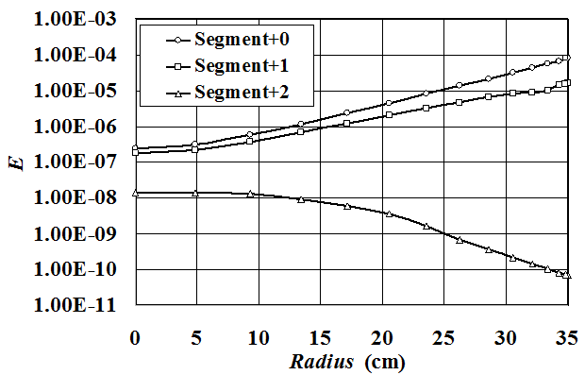

Fig.2. Detection efficiency curves of Cs-137 versus cylindrical radius when the matrix density is 2.5g/cc.

 （4）

The synthetical detection efficiency (*E’*) is defined as



whichcan be calculated directly by calibrations. Then the total count reate (*C*) is simplified as follows.

 （5）

It is equivalent to that all radioactive sources within the waste drum are projected into one plate. *E’* is the synthetical detection efficiency which depends on the source radius. As shown in Fig.2, it is concluded that the detection efficiency will monotonically increases versus the radius, so all sources in the projected plate can be approximated into one ring source with a particular radius of *r* which is called “equivalent radius”. Then the total count rate can be given by

 (6)

Tab.1. Equivalent radius bias (△*r*, cm) between position A and B.

|  |  |  |  |  |  |  |  |
| --- | --- | --- | --- | --- | --- | --- | --- |
| Density | | 1.5 g/cc | | | 2.5 g/cc | | |
| Nuclide | | Ba-133 | Cs-137 | Co-60 | Ba-133 | Cs-137 | Co-60 |
| Sources number | 2 | 0.5 | 0.7 | 0.9 | 0.3 | 0.4 | 0.6 |
| 7 | 1.3 | 1.6 | 2.0 | 0.7 | 1.1 | 1.4 |
| 14 | 1.4 | 1.7 | 2.1 | 0.9 | 1.2 | 1.5 |
| 21 | 1.4 | 1.7 | 2.2 | 0.9 | 1.2 | 1.5 |

here *E’r* is the synthetical detection efficiency of the equivalent ring source with radius of *r*. So far, the total activities (*A*) can be concluded accurately if the equivalent radius is determined.

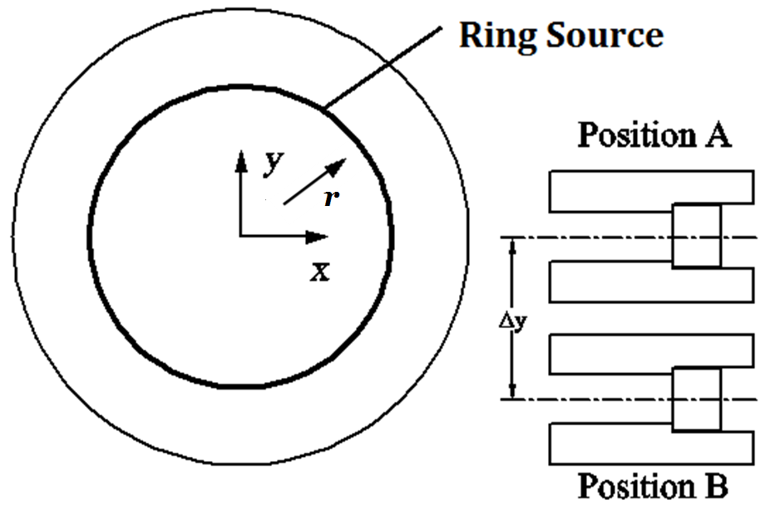

Fig. 3. The schematic of plane layout using two detectors.

 (7)

Using two detectors simultaneously to scan the waste drum or one detector in two positions is the method to identify the equivalent radius. The schematic of detector layout is shown in Fig.3, where the offset of position B to position A is △*y*. The total count rates in position A and B are respectively given by

 (8)

here *E’A* and *E’B* are the synthetical detection efficiencies when the detector is located at position A and B. Fig.4 (a) shows the curves of *E’A* and *E’B* versus source radius where the nuclide is Cs-137, wastes density is 2.5 g/cc and △*y* is 24.5 cm. For multiple sources existing in the waste drum, the equivalent radiuse will be different for position A and B, △*r* is the equivalent radius bias between the two positions. Of course, if there is only one ring source in the segment, the radius bias will be zero (△*r*=0). Otherwise, △*r* is larger than zero because the growth rate of *E’B* is larger than that of *E’A* versus the radius.

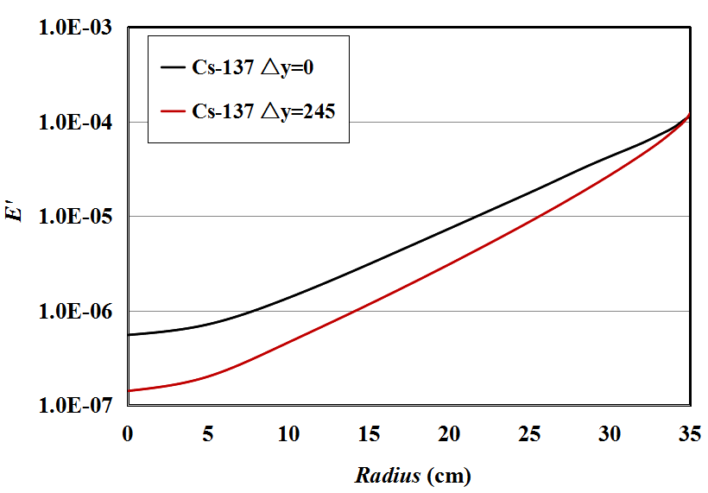

(a) The synthetical detection efficiencies

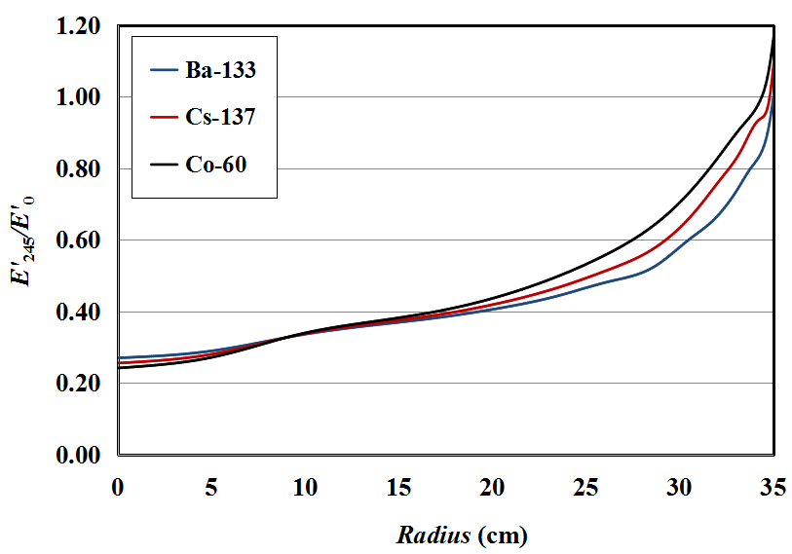

(b) The relative detection efficiencies

Fig. 4. The curves of synthetical detection efficiencies and relative detection efficiencies of Cs-137 versus source radius.

Basing on the statistical analysis of 200 groups of randomly distributed sources, the mean value of △*r* is shown in Tab.1. It is found that △*r* is ranged between 0.5 to 2 cm, depends on nuclide's type, sources number and waste’s density. However, when sources number is 21, △*r* will not grow in a large degree. The mean value is adopted in this paper.

If the two count rates in Eq.(8) are compared, the relative counting rate (*CB/A*) is only related with the ratio of two synthetical detection efficiencies.

 (9)

A function (*F*) is defined as follows.

 (10)

The distribution of *F* versus ring source radius where △*r*=0 is shown in Fig.4 (b) which contains three nuclides, Ba-133, Cs-137 and Co-60. The figure shows that the function of *F* monotonically increases with source radius, so the equivalent radius (*r*) can be concluded according to the relative counting rate (*CB/A*) by Eq.(9). Because the equivalent ring source exists in the projected plate, it will no longer need iteration to reconstruct the distribution in each segments. So far, the accurate detection efficiency can be calibrated if the equivalent radius is calculated, and the total activity will be obtained by Eq.(7).

# Results and discussion

Numerical method is applied in efficiency calibration and radioactive wastes assay process [11]. In order to validate the numerical method, some experiments have been done in the nuclear power plant. The experimental facilities are shown in Fig.5. The waste drum is placed in the rotation plate which driven by a servo motor. The material filled in the standard drum is polyamide with the density of 1.15 g/cc. One Canberra’s pin coaxial high-purity Germanium (HPGe) detector with the efficiency of 40% is adopted to scan the gamma rays emitted from the nuclide inside the drum. The diameter and length of the crystal is 6.2 and 5.95 cm. The crystal is housed by a cylinder lead collimator which has a square hole with a side length of 6 cm and a depth of 25 cm. The gamma scanning detection system presently can satisfy the assay of 200 liter drum, the diameter of the standard drum is 28 cm. One nuclide of Cs-137 is placed in the hole within the matrix whose radial distance to the drum axis is 9 cm. Fig.6 shows the count rate of gamma rays full energy peaks versus the drum rotation angle where the drum is rotated by 15º per step and then gamma rays is collected by the detector. In the figure, E and S denote the data obtained by experiments and simulation respectively. Because the detector will be changed its position in *y* direction, two cases of position offset (△*y*=3.5 and 17.5 cm) are selected. It is found that the data obtained by the simulation well agree with the experimental data, the relative error of the curve peak is 3% and 5% for the two cases respectively.

Tab.2. The comparison of experimental results between SGS and improved method.

|  |  |  |  |  |  |  |
| --- | --- | --- | --- | --- | --- | --- |
| Nuclide | *rreal* | *C*Δy=0 | *C*Δy=14 | SGS | IM | |
| (cm) | (1/s) | (1/s) | *A*/*Areal* | *r* | *A*/*Areal* |
| Cs-137 | 0 | 71 | 3 | 0.63 | 0 | 0.94 |
| 8 | 78 | 23 | 0.69 | 7 | 0.95 |
| 24 | 128 | 123 | 1.14 | 23 | 0.97 |
| Co-60 | 0 | 77 | 5 | 0.85 | 0 | 0.91 |
| 8 | 80 | 27 | 0.88 | 7 | 0.92 |
| 24 | 94 | 99 | 1.03 | 23 | 0.94 |

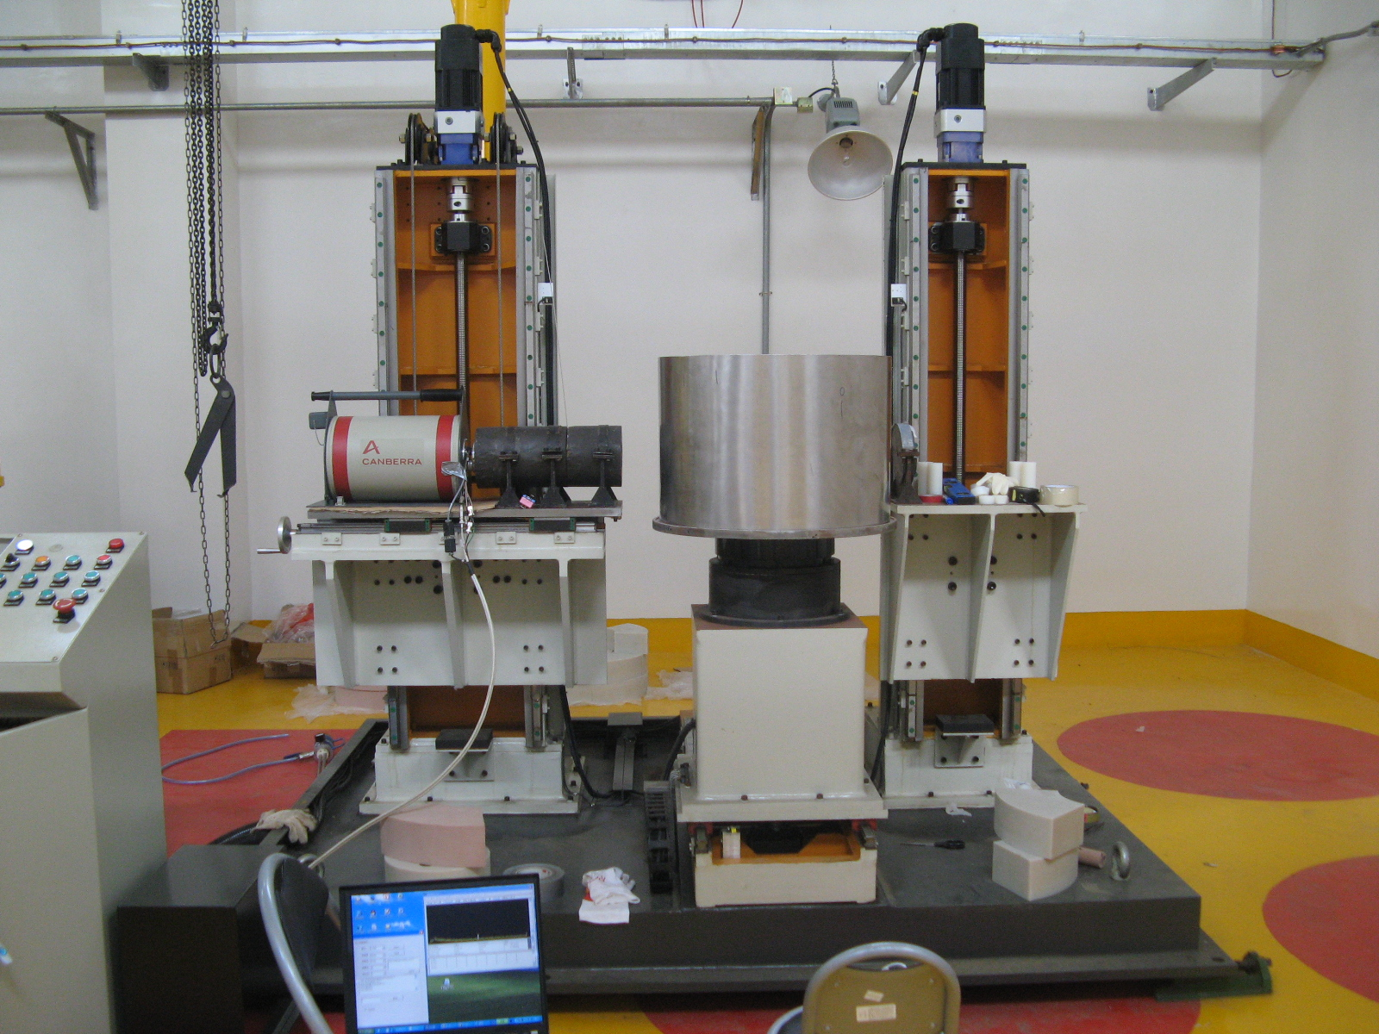

(a) Gamma rays scanning detection system

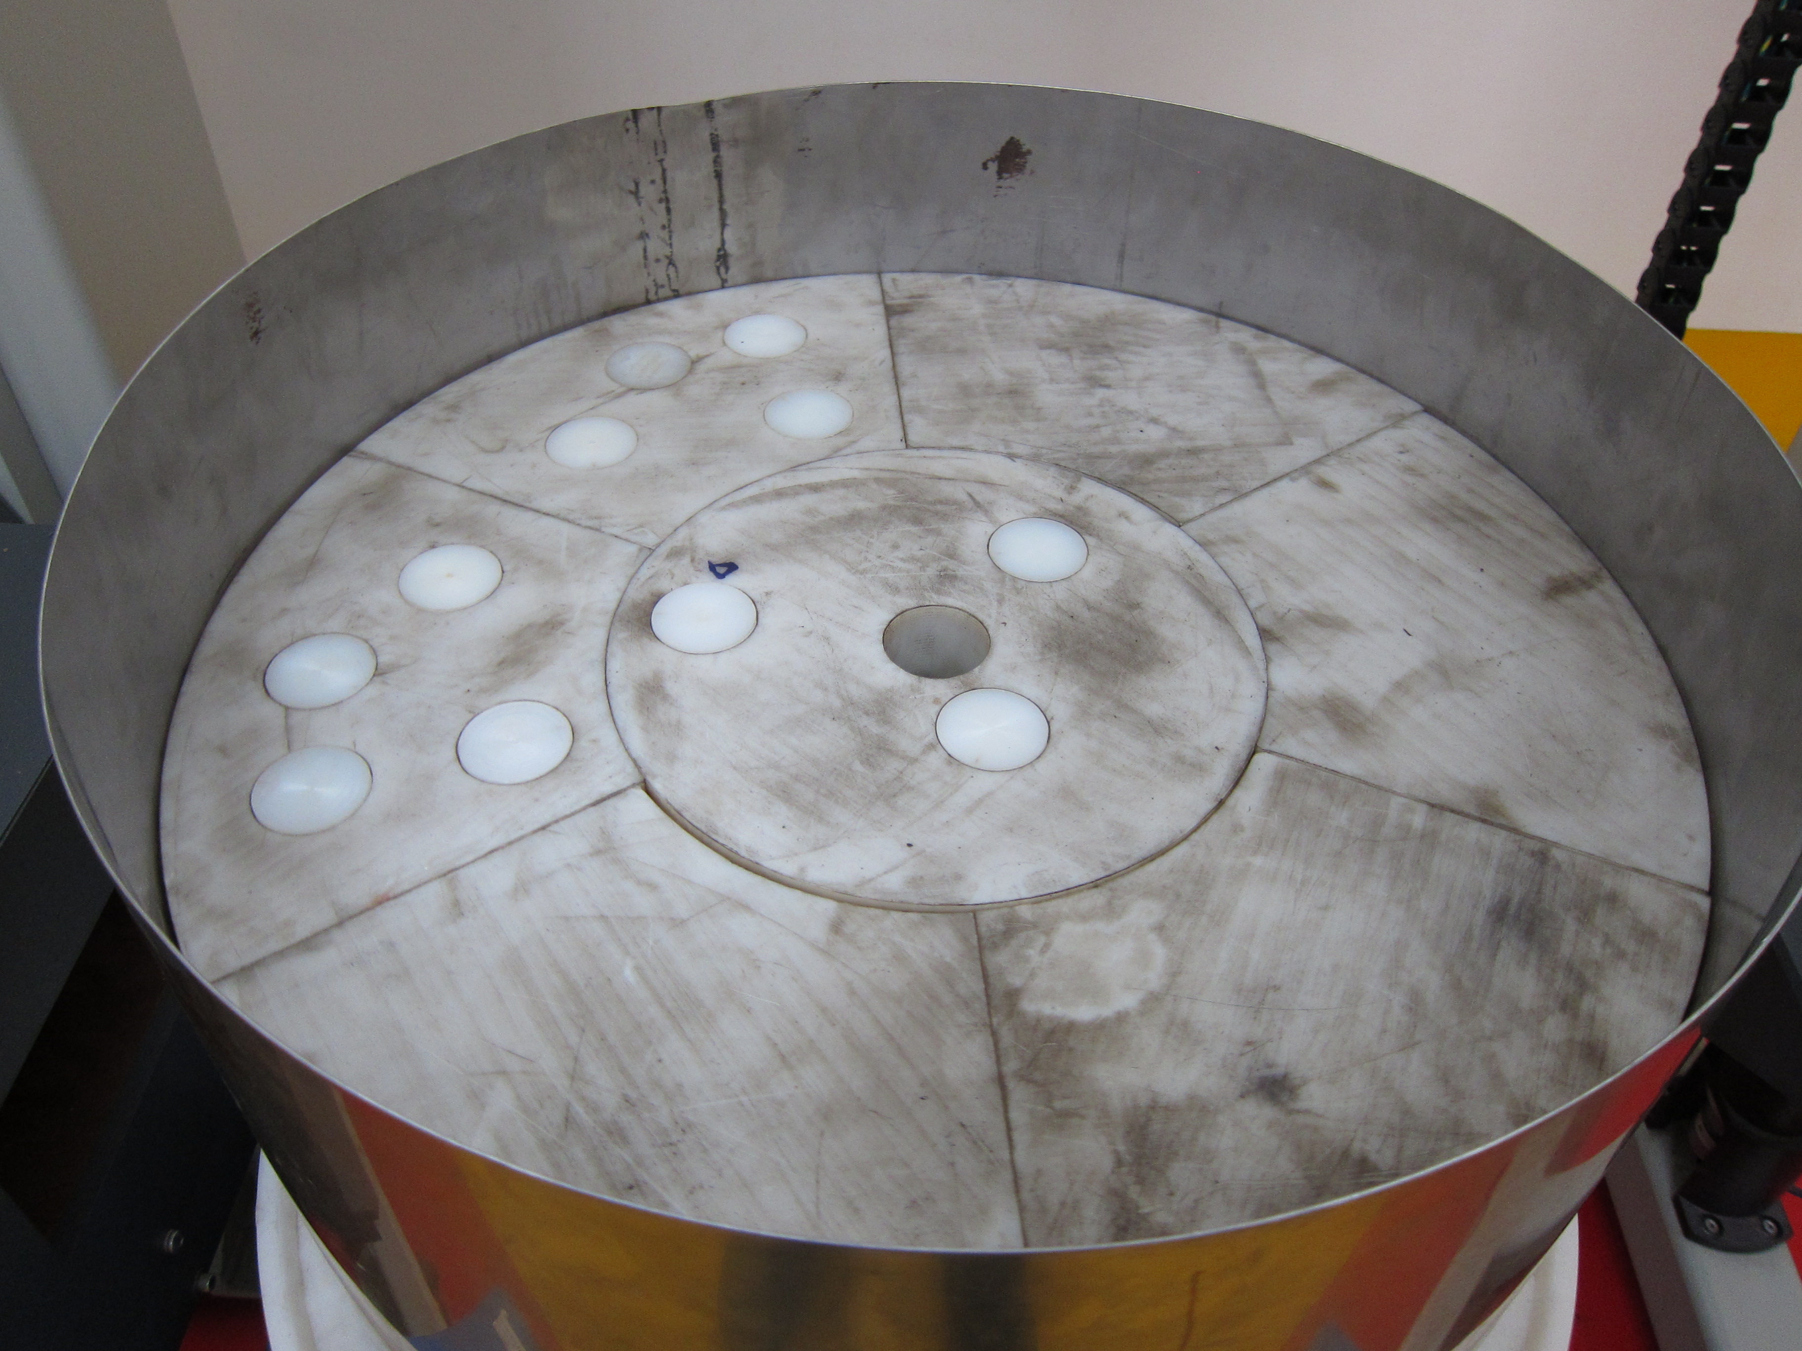

(b) Polyamide matrix with density of 1.15 g/cc

Fig. 5. The experimental facilities which assays the low and intermediate radioactive waste drum by gamma scanning method.

Fig. 6. The comparison of gamma rays count rate (*C*) versus drum rotation angle between experiments and numerical method.

The standard drum was assayed in the experiment by SGS and the improved method (IM). The drum contains polyamide matrix and Cs-137, Co-60 point sources located in the holes with radial distance to drum axis of 0, 8, 24 cm respectively. The results are shown in Tab.2 including the count rate (*C*) by the detector with two positions. It is found that the improved method has identified the source positions very approaching to the real radius, and exhibits the reconstructed activity also very close to the real activity because their ratio is larger than 0.9. At the same time, the minimal ratio of SGS is 0.63 for Cs-136 and 0.85 for Co-60, which indicates the error of the activity reconstruction will be 37% and 15% of the real activities. The accuracy of SGS depends on the distribution of detection efficiency versus the ring source radius, and is comparatively good for Co-60 for its high penetrability in small density matrix.

Since the detection system can not satisfy the assay of 400 liter radioactive wastes drum, the measurement has to be simulated by numerical method. The diameter and height of the standard 400 liter drum are 70 and 105 cm. The detector is similar with the experimental one, but the collimator hole becomes large with a side width of 12 cm. Three common nuclides, Ba-133 (0.356 MeV), Cs-137 (0.662 MeV) and Co-60 (1.333 MeV) are selected. The waste drum is assumed to be contained by highly compressed materials except metal wastes, the gamma rays’ mass attenuation coefficients are set to 0.11, 0.075 and 0.054 cm2/g for these three nuclides. Two cases of matrix density are considered including 1.5 and 2.5 g/cc. The waste drum is divided into 7 segments, and the segmental height is 15cm.

In order to verify the identification of equivalent radius by the new improved method, a line source with length of 105 cm is set in the waste drum parallelly to the drum axis. The reconstructed results are shown in Fig.7, where *Arc* is the reconstructed radioactivity of one nuclide, *Areal* is the preset activity in simulation, *Rsource* is the radial coordinate of the line source. If the ratio between *Arc* and *Areal* is equal to 1, it is indicated that the reconstructed activity well agrees with the real activity. It is found that when traditional SGS is applied, the ratio markedly deviates from 1 especially when the source is located near the drum axis or near the wall. With the density increases from 1.5 to 2.5 g/cc, the extreme value of *Arc/Areal* is close to 0.1 (e.g. Co-60), which means the reconstructed activity is only 10% of the real activity. The error is even larger for the other two nuclides whose characteristic apex energy is comparatively smaller than that of Co-60. At the same time, the ratio by the improved method very approaches to 1 wherever the source is located. The extreme value of *Arc/Areal* by IM is 1.65, 1.21 and 1.08 for Ba-133, Cs-137 and Co-60 respectively when the density is 2.5 g/cc. Fig.8 displays the source radius identified by the improved method which is proved to very agree with the real radius. The comparatively large errors mainly appear in the center area in the waste drum, for example where the radius is less than 10 cm as shown in Fig.8 (b), which is probably caused by that the ratio of detection efficiencies as shown in Fig.4 (b) is distributed comparatively flat, which leads to the increasing difficulty in identifying the equivalent radius.

Tab.2. The maximal and mean reconstructed errors for 7 radioactive sources in the waste drum.

|  |  |  |  |  |  |
| --- | --- | --- | --- | --- | --- |
| Nuclide | Δ | Density=1.5g/cc | | Density=2.5g/cc | |
| SGS | IM | SGS | IM |
| Ba-133 | Max. | 2.96 | 2.01 | 8.06 | 3.11 |
| Mean | 1.34 | 1.19 | 1.66 | 1.43 |
| Cs-137 | Max. | 2.03 | 1.58 | 4.13 | 2.53 |
| Mean | 1.23 | 1.10 | 1.46 | 1.29 |
| Co-60 | Max. | 1.51 | 1.40 | 2.56 | 1.91 |
| Mean | 1.14 | 1.05 | 1.30 | 1.15 |

Tab.3. The maximal and mean reconstructed errors for 14 radioactive sources in the waste drum.

|  |  |  |  |  |  |
| --- | --- | --- | --- | --- | --- |
| Nuclide | Δ | Density=1.5g/cc | | Density=2.5g/cc | |
| SGS | IM | SGS | IM |
| Ba-133 | Max. | 2.05 | 1.67 | 3.29 | 2.64 |
| Mean | 1.21 | 1.16 | 1.39 | 1.32 |
| Cs-137 | Max. | 1.64 | 1.30 | 2.48 | 1.87 |
| Mean | 1.14 | 1.08 | 1.28 | 1.21 |
| Co-60 | Max. | 1.32 | 1.15 | 1.89 | 1.45 |
| Mean | 1.08 | 1.04 | 1.19 | 1.12 |

In the real waste drum, multiple radioactive sources will exist and be complicatedly distributed. Accordingly, 7 and 14 identical nuclides with random activity are simultaneously set in one drum with uniform random positions. Totally 100 waste drums are statistically analysed.

The geometric mean of *Arc/Areal* is used to compare the detection accuracy. In order to avoid the neutralization of the values which are larger or less than 1,Δ is defined as follows.

Tab.4. The maximal and mean reconstructed errors for 7 radioactive sources in the waste drum.

|  |  |  |  |  |  |
| --- | --- | --- | --- | --- | --- |
| Nuclide | Δ | Density=1.5g/cc | | Density=2.5g/cc | |
| SGS | IM | SGS | IM |
| Ba-133 | Max. | 2.96 | 2.01 | 8.06 | 3.11 |
| Mean | 1.34 | 1.19 | 1.66 | 1.43 |
| Cs-137 | Max. | 2.03 | 1.58 | 4.13 | 2.53 |
| Mean | 1.23 | 1.10 | 1.46 | 1.29 |
| Co-60 | Max. | 1.51 | 1.40 | 2.56 | 1.91 |
| Mean | 1.14 | 1.05 | 1.30 | 1.15 |

Tab5. The maximal and mean reconstructed errors for 14 radioactive sources in the waste drum.

|  |  |  |  |  |  |
| --- | --- | --- | --- | --- | --- |
| Nuclide | Δ | Density=1.5g/cc | | Density=2.5g/cc | |
| SGS | IM | SGS | IM |
| Ba-133 | Max. | 2.05 | 1.67 | 3.29 | 2.64 |
| Mean | 1.21 | 1.16 | 1.39 | 1.32 |
| Cs-137 | Max. | 1.64 | 1.30 | 2.48 | 1.87 |
| Mean | 1.14 | 1.08 | 1.28 | 1.21 |
| Co-60 | Max. | 1.32 | 1.15 | 1.89 | 1.45 |
| Mean | 1.08 | 1.04 | 1.19 | 1.12 |

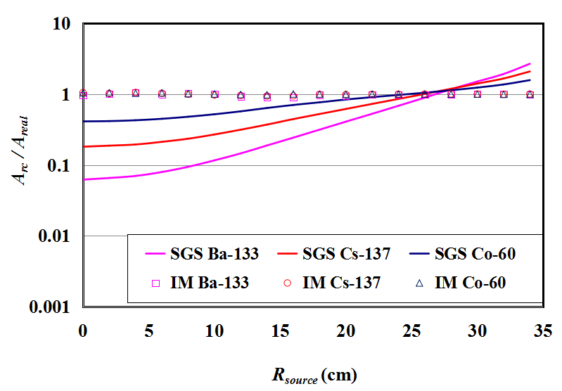

(a) Density=1.5 g/cc

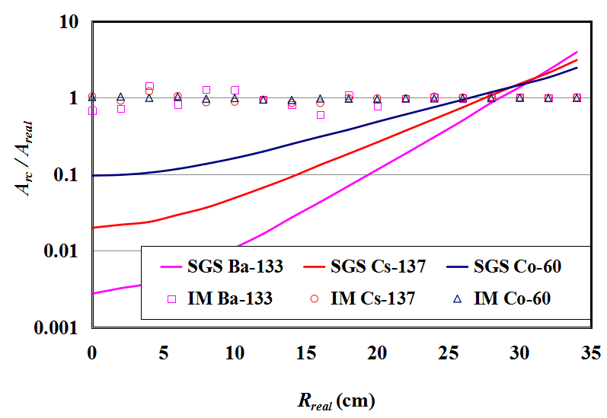

(b) Density=2.5 g/cc

Fig. 7. The reconstructed results for a line source which is inside the drum and parallel to the drum axis.



Here, Max and Min denote the large and small value by comparing *Arc* and *Areal*. The geometric mean is calculated by



where *N* is the total number of samples. So it presents the statistical deviation of reconstructed activity from the real activity.

Table 4 and 5 show the maximal and geometric mean of Δ in assaying the waste drums whose density includes 1.5 and 2.5 g/cc containing 7 and 14 randomly distributed sources. It is found in the tables that the detection accuracy will be improved when the nuclide becomes from the low energy to high energy. Especially for SGS, when the matrix density is 2.5 g/cc as shown in table 4, the maximal Δ for Ba-133, Cs-137 and Co-60 is 8.06, 4.13 and 2.56, which means that the reconstructed activity will probably be about 8, 4 and 2.6 times larger or smaller than the real activity. It is indicated that the enhancement of gamma penetrating will reduce the assay error because detection efficiency will not change in a large degree versus the source positions. At the same time, the improved method distinctly reduces the detection error which will be found in both the maximal and mean Δ. When the density is 1.5 g/cc in table 4, the mean Δ of Co-60, for example, is 1.14 for SGS and 1.05 for IM, which represents the relative error of reconstructed activities is 14% and 5% of the real activities. Similarly, the mean Δ by IM is nearly half of that by SGS for Ba-133 and Cs-137. When the density increases to 2.5 g/cc, the relative errors for both SGS and IM is nearly double. The mean relative error by IM is 43% for Ba-133, 29% for Cs-137 and 15% for Co-60, which are about one thirds or a half less than that of SGS.

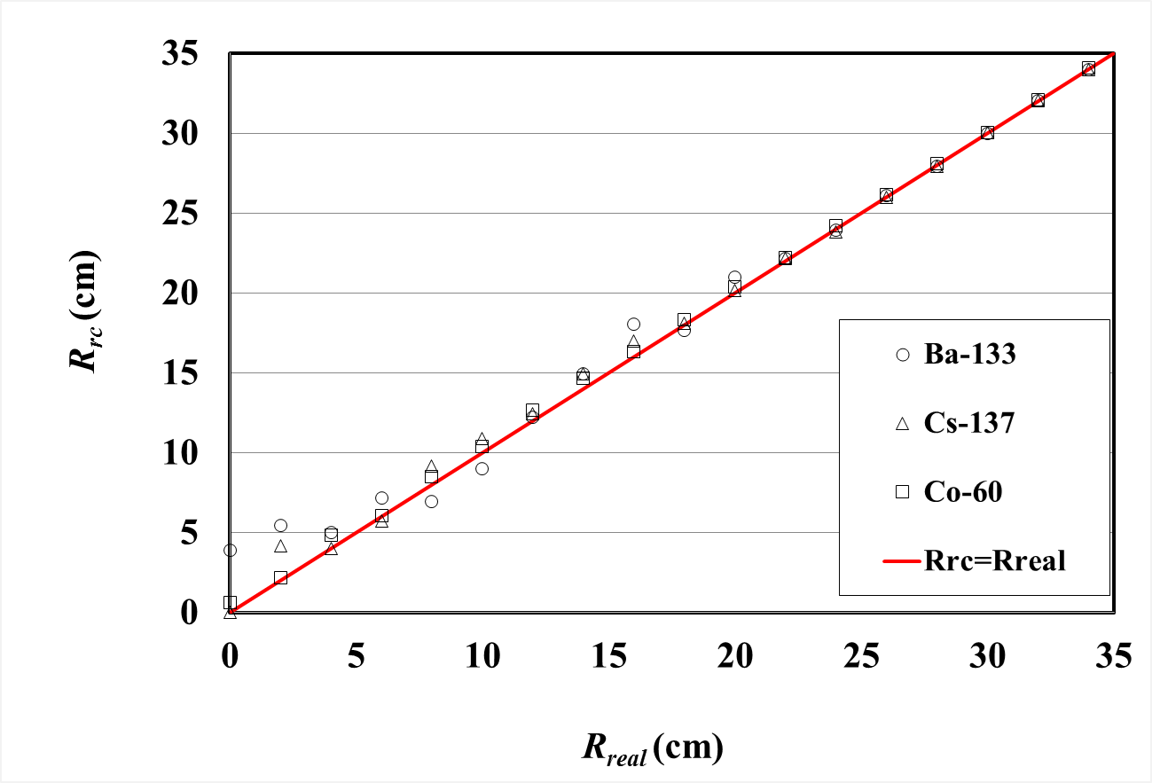

(a) Density=1.5 g/cc

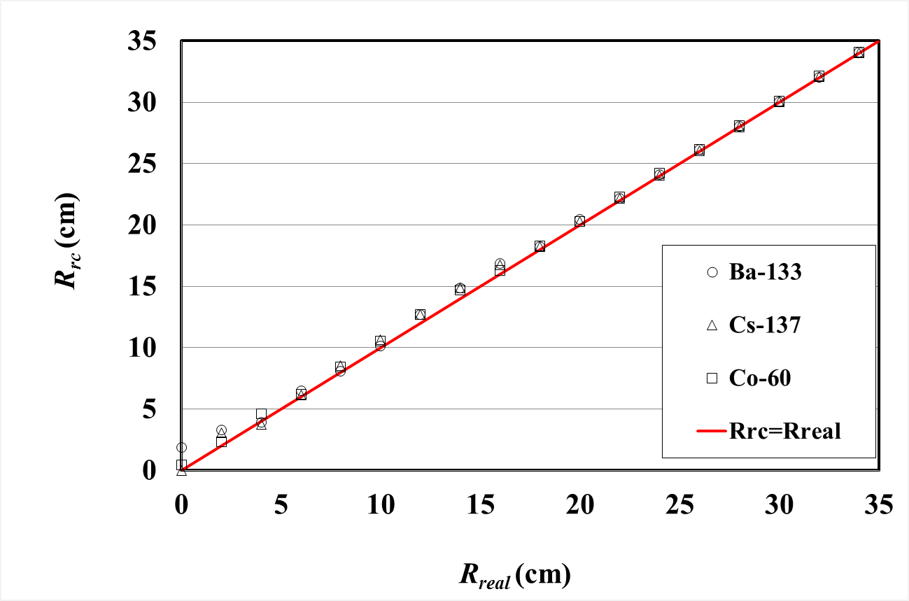

(b) Density=2.5 g/cc

Fig. 8. The identified radius of a line source which positioned in the waste drum parallelly to the drum axis.

When the sources number increases, the sources distribution will become increasingly uniform, so the assay error is further reduced especially for SGS as shown in Tab.5. The mean relative error of SGS is almost less than 20% when density is 1.5 g/cc, and is less than 40% when density is 2.5 g/cc for all nuclides. Meanwhile, the mean relative error by IM is also smaller and less 5% and 7% than that of SGS when the matrix density is 1.5 and 2.5 g/cc. It can be foreseen that when more sources exist in the waste drum, the assay error of SGS will accordingly be reduced. In this situation, the improved method will also exhibit the high assay accuracy because the equivalent radius is innate and can be concluded even for the uniform distribution of activities.

# CONCLUSION

One improved gamma scanning assay and its algorithm are proposed aiming at 400 liter drum with low and intermediate level radioactive wastes which are highly compressed. In the improved method, the nuclides in the waste drum are supposed to be projected into one plate and approximated to a ring source. The equivalent radius of the ring source is estimated by applying two detectors, so that the detection accuracy is markedly improved by accurate calibration basing on the equivalent radius.

Three common nuclides (Ba-133, Cs-137, Co-60) and two waste densities (1.5, 2.5 g/cc) are selected for contrastive analysis. The reconstructed results show that the improved method distinctly exhibits the very good performance in detecting the large and highly compressed radioactive wastes drum. The performance depends on the waste's density, nuclide's type and sources' number, but the whole maximal errors of the improved method are several times smaller than that of SGS, and the mean errors are reduced nearly in half for all nuclides.

With the increase of sources number, the detection accuracy of SGS is gradually improved and increasingly close to that of the improved method. However, due to the difficulty in judging the sources distribution in practical waste drums, the proposed method is efficient and promising especially for the compressed waste drums whose radioactive sources will be finite and heterogeneous.

References

1. Martin E.R., Jones D.F., and Parker J.L., “Gamma-ray measurements with the segmented gamma scanner”. Technical Report LA-7059-M, Los Alamos Scientiﬁc Laboratory, 1977.
2. Bronson F., Atrashkevich V., Geurkov G., Young B., “Probabilistic uncertainty estimator for gamma-spectroscopy measurements”. J. Radioanal. Nucl. Chem. 2008, 276(3), 589–594.
3. Estep R.J., Prettyman T.H., Sheppard G.A., “Tomographic gamma scanning to assay heterogeneous radioactive waste”. Nuclear science and engineering, 1994, 118: 145-152.
4. Ramkumar Venkataraman, Marcel Villani, et al., “An integrated Tomographic Gamma Scanning system for non-destructive assay of radioactive waste”. Nuclear Instruments and Methods in Physics Research A, 2007, 579: 375-379.
5. LIU Cheng, GU Weiguo, QIAN Nan, WANG Dezhong, “Study of Image Reconstruction Using Dynamic Grids in Tomographic Gamma Scanning”. Nuclear Science and Techniques, 2012, 23(5): 277-283.
6. Weiguo GU，Cheng LIU，Nan QIAN，Dezhong WANG, “Study on detection simplification of tomographic gamma scanning using dynamic grids applied in the emission reconstruction”. Annual of Nuclear Energy, 2013, 58: 113-123.
7. Weiguo Gu, Kaiyuan Rao, Dezhong Wang, and Jiemei Xiong, “Semi-tomographic gamma scanning technique for non-destructive assay of radioactive waste drums”. IEEE Transactions on Nuclear Science, 2016, 63 (6): 2793-2800.
8. Stanga D., Gurau D., “A new approach in gamma-ray scanning of rotating drums containing radioactive waste”. Applied Radiation and Nuclides, 2012, 70: 2149-C2153.
9. LIU Cheng, WANG Dezhong, BAI Yunfei, QIAN Nan, “An improved segmented gamma scanning for radioactive waste drums”. Nuclear Science and Techniques, 2010, 21(4): 204-208.
10. Tran Thien Thanh, Hoang Thi Kieu Trang, et al., “A prototype of radioactive waste drum monitor by non-destructive assays using gamma spectrometry”. Applied Radiation and Nuclides, 2016, 109: 544-546.
11. Nan Qian, Thomas Krings, Eric Mauerhofer, Dezhong Wang, Yunfei Bai, “Analytical calculation of the collimated detector response for the characterization of nuclear waste drums by segmented gamma scanning”, J. Radioanal Nucl. Chem., 2012, 292:1325–1328.

1. Corresponding author. **dzwang@sjtu.edu.cn**